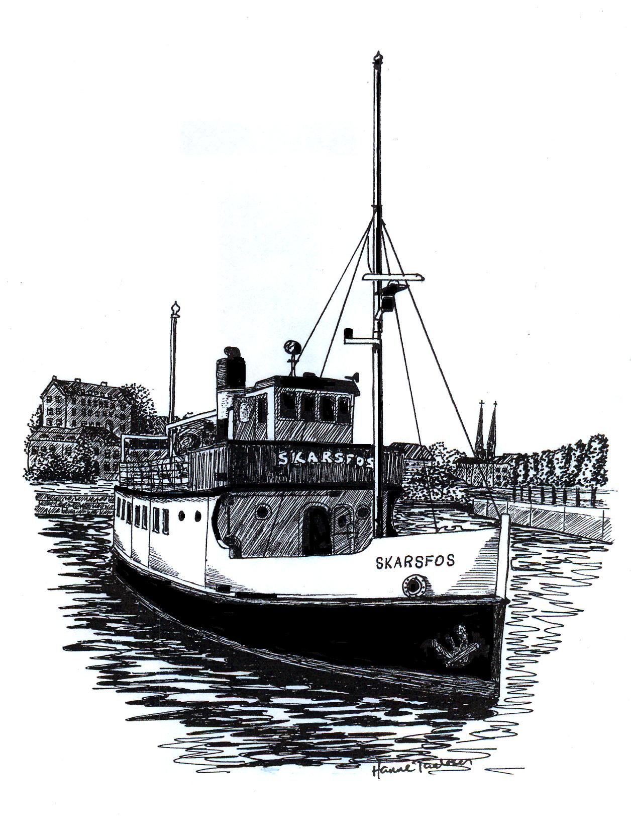

Båttur med M/S Skarsfos

Til: ____________________________________

JEG/VI VIL I ANLEDNING:
_____________________________________________________________________________________________

INVITERE DEG/DERE MED OM BORD PÅ M/S SKARSFOS
DEN: __________________ KLOKKEN:________________________
AVREISE FRA: __________________ KLOKKEN:________________________
REISEMÅL: _______________________________________________________________________________
MENY:_____________________________________________________________________________________
DRIKKE:___________________________________________________________________________________
PRIS PER PERSON: ________________________ PÅMELDING INNEN:____________________
ANTREKK:________________________________________________________________________________

VENNLIG HILSEN

____________________________________________________ TLF:_______________________________

M/S SKARSFOS v/Asbjørn Lia
Røråstangen 80, 3720 SKIEN
Tlf: 907 63 686 Faks: 35 53 91 13
Mail: info@skarsfos.no Hjemmeside: www.skarsfos.no

